**UHS contact details:** [**ribfixation@uhs.nhs.uk[](mailto:uhs.ribsfixation@nhs.net)**](mailto:ribfixation@uhs.nhs.uk#) **| SpR on call: 9211 or 1032**

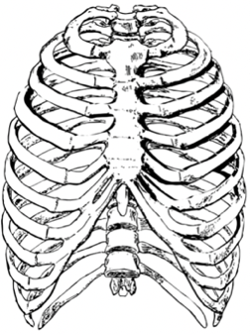

**Patient Name:**

**DOB (DD/MM/YYYY):**

**NHS ID:**

**Referring Hospital:**

**Referring team:**

**Team contact number:**

**Date of injury:**

**Polytrauma**:  **Isolated Chest Trauma:**  **Blunt:**  **Open:**

**If polytrauma, please list concomitant injuries:**

**Major Criteria:**

**Flail segment**: Yes  No

**≥ 3 displaced fractures:** Yes  No

Minor Criteria:

Unable to cough/mobilise: YesNo

Uncontrollable pain: Yes  No

High/increasing O2 support: Yes  No

**Fractured ribs on right side (e.g. 3-7 or 2,4,7-9): __________________**

**Fractured ribs on left side (e.g. 3-7 or 2,4,7-9): __________________**

**Fractured Sternum**: Yes  No

**Ventilatory Support:** Invasive  NIV  Mask/Nasal specs  Air

**Relevant comorbidities**:

**\*For in hour referrals, please email this form to** [**ribfixation@uhs.nhs.uk[](mailto:uhs.ribsfixation@nhs.net)**](mailto:ribfixation@uhs.nhs.uk#)

**\*For OUT OF HOURS referrals, please email this form to** [**ribfixation@uhs.nhs.uk[](mailto:uhs.ribsfixation@nhs.net)**](mailto:ribfixation@uhs.nhs.uk#) **and inform SpR on call**